
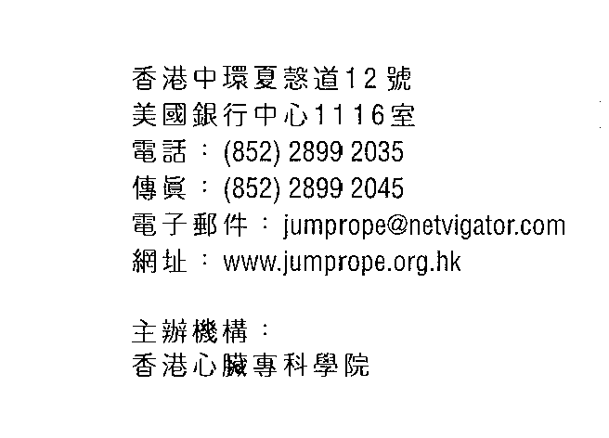

Jump Rope for Heart – Star Program
Award List
School：
Teacher： |  |  |  | Tel：
Assessment Level： |  | rRed rGreen rYellow  rSilver rGold |  | Assessment Date：

 | Name (Chinese) | Name（English） | ID Card No. | Sex | Class | Remarks
1
2
3
4
5
6
7
8
9
10
11
12
13
14
15
16
17
18
19
20

F-19ver.8/2024

